10 Useful Linux Commands with Examples
1. which
The which command displays the path of an executable command available in the system's PATH.
It helps identify which executable will run when a command is entered.
Example:
which python3
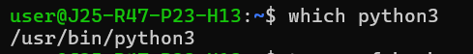
2. tar
The tar command is used to create and extract archive files containing multiple files or directories.
It is useful for packaging files for backups and transferring them between systems.
Example:
tar -cvf backup.tar documents/
3. curl
The curl command transfers data between a system and a URL using protocols such as HTTP and HTTPS.
It is commonly used to test APIs, check website responses, and troubleshoot network connectivity.
Example:
curl -I https://example.com
4. wget
The wget command downloads files from web servers using a URL.
It is useful for downloading installation packages, documents, and other resources from the internet.
Example:
wget https://example.com/file.zip
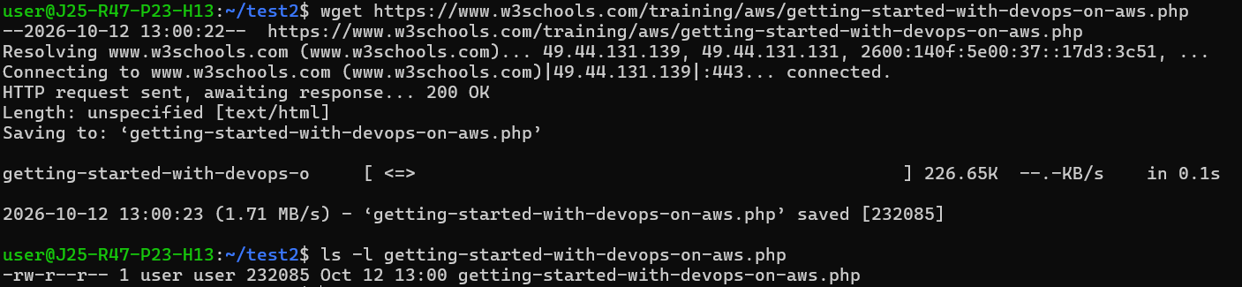
5. history
The history command displays previously executed commands in the current shell's command history.
It helps users recall commands and repeat earlier tasks without typing them again.
Example:
history 10
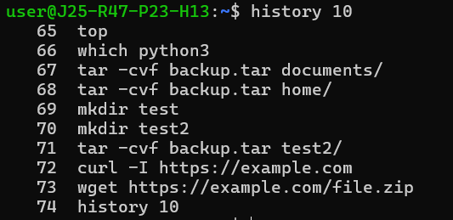
6. date
The date command displays the system's current date and time.
It can also format date and time output for use in scripts and log files.
Example:
date +"%d-%m-%Y"
7. uptime
The uptime command displays how long the system has been running since its last boot.
It also shows the number of logged-in users and the system load averages.
Example:
Uptime
8. kill
The kill command sends a signal to a process identified by its process ID (PID).
It is commonly used to request that an unresponsive application terminate gracefully.
Example:
kill 1234
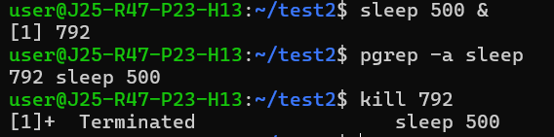
& starts a process and makes it run in the background.
Pgrep helps to find the process id.
9. du
The du command estimates the disk space used by files and directories.
It helps identify directories that consume significant storage space on a Linux system.
Example:
du -sh Documents/
10. sort
The sort command arranges lines of text in alphabetical or numerical order.
It is useful for organizing text files and processing command output.
Example:
sort names.txt
